**Does the unemployment rate affect job satisfaction?**

Potential further study: Former vs current especially during dip

Yes, it appears so. We found that Glassdoor ratings appear to go down during times when unemployment rates are high as you can see in the plot below.

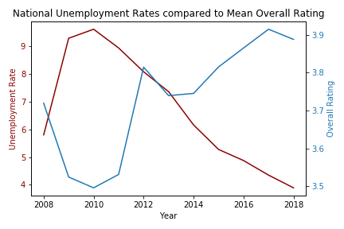

In order to find this out, we started by finding unemployment data from the Bureau of Labor Statistics. We compared the overall national unemployment rate to the unemployment rate for people over 25 with bachelor’s degrees. Most office workers fall into the latter category so we wanted to confirm that the unemployment rate for that category followed the same trend as overall national unemployment rates. As can be seen in the graph below, it is a very similar trend. We chose to use the overall unemployment for our comparison because there are many people who work for all 5 of these countries who are not over 25 or do not have bachelor’s degrees so it is a more accurate predictor.

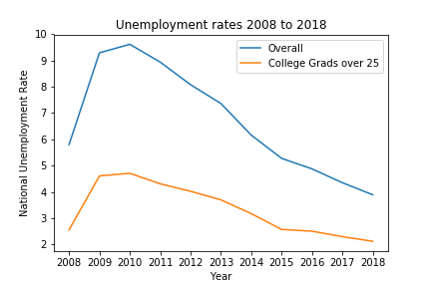After confirming our unemployment data, we then found the mean “Overall Rating” for each company for each year and compared them to each other. This can be seen in the graph below. As can be seen, almost every company experience a dip in their overall ratings around 2009-2010 which corresponds with the unemployment rate and of course the “Great Recession”. Of course, this doesn’t necessarily mean that that is the only factor involved but it is likely given the overall trend. Facebook is the outlier in this trend. However, Facebook had less than 50 reviews for this entire time frame which can impact the validity of their reviews. There are also any number of outside factors that we can’t see here that could impact the happiness (or unhappiness!) of these reviewers.

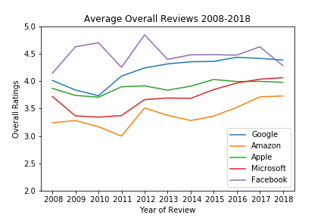

There are several limits and potential issues with this data. A major limitation of this dataset is the number of reviews. In regards to comparisons with unemployment, 2009-2010 are the years with the highest unemployment rates and thus the most likely to have an impact on potential reviews. However, as you can see below, those years also have much fewer reviews than more recent years. This can be attributed to the fact that Glassdoor was very new in those days (founded in 2007) and thus there were less people aware of the service or even thinking about reviewing their employer online. This has grown quite a lot over the last ten or so years which can impact the averages of datasets. It also raises other questions. Perhaps people who were unhappy with their employers were more likely to seek out a service like Glassdoor in the early days (similar to the common compliant that Yelp attracts the very happy and the very unhappy but not the middle reviewers). It’s also possible that in recent years, happier employees have been encouraged to write positive reviews as they have used them themselves or any number of other reasons.

